 | 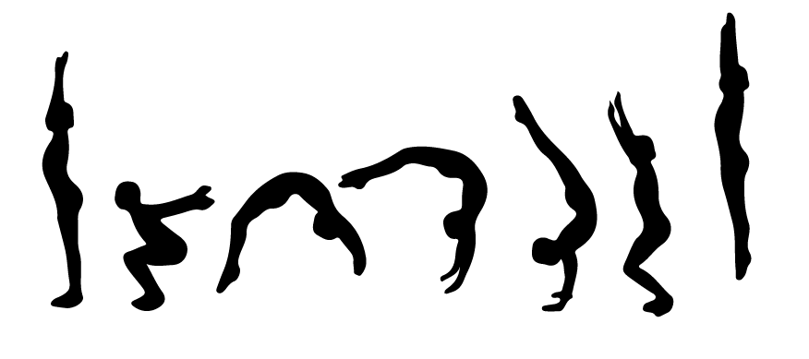 | Class Schedule for  Months of Sept, Oct, Nov, and Dec.
 | Morning | Evening
M |  | Hip Hop & Cheer/Pom  5:15-5:45pm
T
W |  | Tumbling & Gymnastics  5:15-5:45pm  5:50-6:20pm  6:25-7:00pm
T |  | Into to Ballet  5:45-6:15pm
F
S
S

Family Weekly Calendar
Week of ______________

 | M | T | W | T | F | S | S

Morning

Evening

